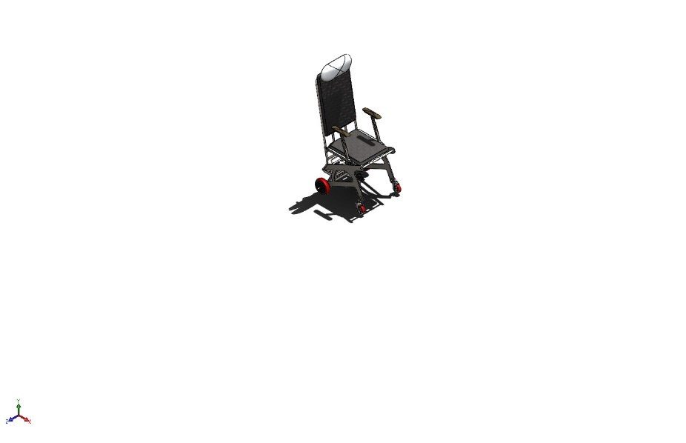 | Simulation of assem_main  Date: Sunday, January 12, 2025  Designer: Solidworks  Study name: Static 1  Analysis type: Static  Table of Contents  Description 1  Assumptions 2  Model Information 3  Study Properties 7  Units 7  Material Properties 8  Loads and Fixtures 11  Connector Definitions 12  Interaction Information 15  Mesh information 15  Sensor Details 15  Resultant Forces 16  Beams 16  Study Results 17  Conclusion 21

Description
No Data

Assumptions

Model Information

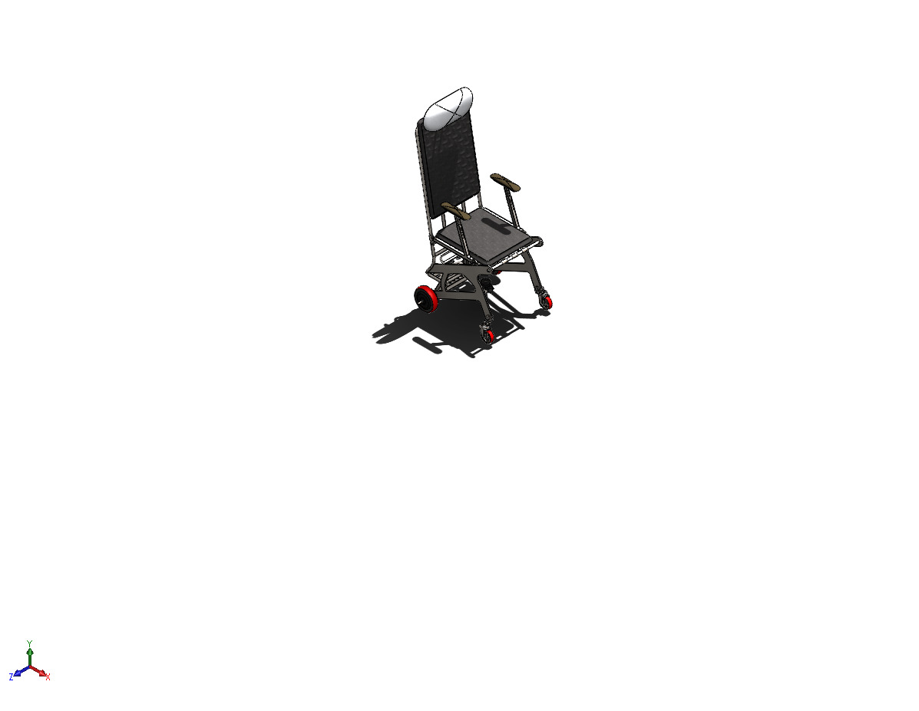
Model name: assem_main
Current Configuration: Default
Solid Bodies
Document Name and Reference | Treated As | Volumetric Properties | Document Path/Date Modified
Fillet29  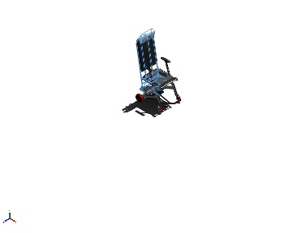 | Solid Body | Mass:77.2016 kg  Volume:0.00982399 m^3  Density:7,858.48 kg/m^3  Weight:756.576 N | C:\Users\User\Desktop\All BE Designs\Solidworks\jetchair_it1\Iteration1.SLDPRT  Dec 24 17:28:36 2024
Dome1  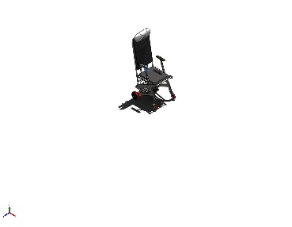 | Solid Body | Mass:2.94215 kg  Volume:0.000374392 m^3  Density:7,858.46 kg/m^3  Weight:28.833 N | C:\Users\User\Desktop\All BE Designs\Solidworks\jetchair_it1\arm_rest.SLDPRT  Dec 22 23:58:49 2024
Dome1  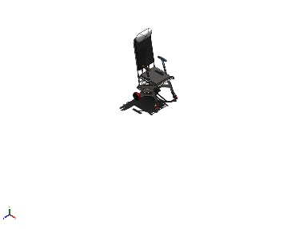 | Solid Body | Mass:2.94215 kg  Volume:0.000374392 m^3  Density:7,858.46 kg/m^3  Weight:28.833 N | C:\Users\User\Desktop\All BE Designs\Solidworks\jetchair_it1\arm_rest.SLDPRT  Dec 22 23:58:49 2024
Cut-Extrude3  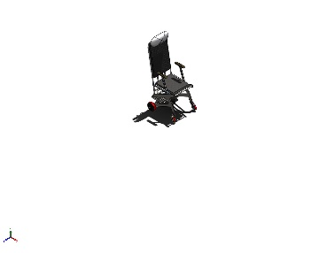 | Solid Body | Mass:0.953336 kg  Volume:0.00012132 m^3  Density:7,858 kg/m^3  Weight:9.3427 N | C:\Users\User\Desktop\All BE Designs\Solidworks\jetchair_it1\beam_arm.SLDPRT  Dec 22 23:58:51 2024
Cut-Extrude3  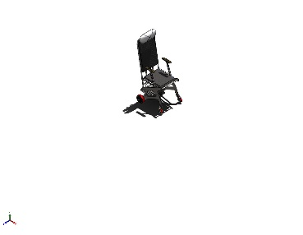 | Solid Body | Mass:0.953336 kg  Volume:0.00012132 m^3  Density:7,858 kg/m^3  Weight:9.3427 N | C:\Users\User\Desktop\All BE Designs\Solidworks\jetchair_it1\beam_arm.SLDPRT  Dec 22 23:58:51 2024
Fillet4  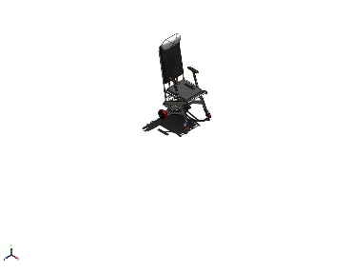 | Solid Body | Mass:0.110445 kg  Volume:1.40551e-05 m^3  Density:7,858 kg/m^3  Weight:1.08236 N | C:\Users\User\Desktop\All BE Designs\Solidworks\jetchair_it1\bracket.SLDPRT  Dec 22 23:58:51 2024
Fillet4  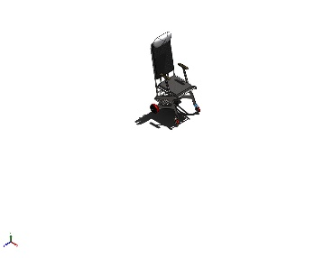 | Solid Body | Mass:0.110445 kg  Volume:1.40551e-05 m^3  Density:7,858 kg/m^3  Weight:1.08236 N | C:\Users\User\Desktop\All BE Designs\Solidworks\jetchair_it1\bracket.SLDPRT  Dec 22 23:58:51 2024
ThdSchPat  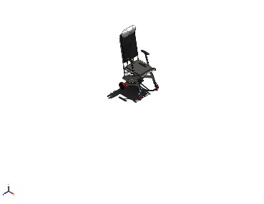 | Solid Body | Mass:0.120094 kg  Volume:1.5283e-05 m^3  Density:7,858 kg/m^3  Weight:1.17692 N | c:\solidworks data (2)\browser\ansi metric\bolts and screws\hex head\heavy hex flange screw_am.sldprt  Dec 8 12:17:11 2024
ThdSchPat  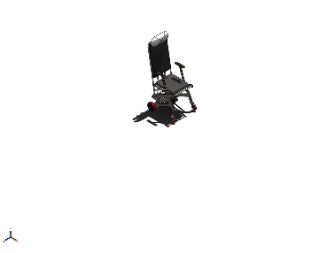 | Solid Body | Mass:0.120094 kg  Volume:1.5283e-05 m^3  Density:7,858 kg/m^3  Weight:1.17692 N | c:\solidworks data (2)\browser\ansi metric\bolts and screws\hex head\heavy hex flange screw_am.sldprt  Dec 8 12:17:11 2024
EndChamfer  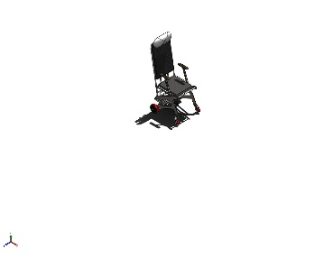 | Solid Body | Mass:0.0227021 kg  Volume:2.88905e-06 m^3  Density:7,857.99 kg/m^3  Weight:0.222481 N | c:\solidworks data (2)\browser\ansi metric\nuts\hex nuts\hex flange nut_am.sldprt  Jan 3 19:38:50 2025
EndChamfer  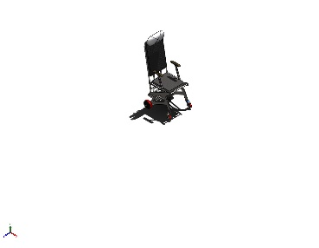 | Solid Body | Mass:0.0227021 kg  Volume:2.88905e-06 m^3  Density:7,857.99 kg/m^3  Weight:0.222481 N | c:\solidworks data (2)\browser\ansi metric\nuts\hex nuts\hex flange nut_am.sldprt  Jan 3 19:38:50 2025
LPattern1  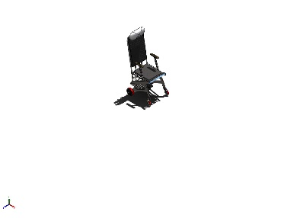 | Solid Body | Mass:0.474378 kg  Volume:6.03688e-05 m^3  Density:7,858 kg/m^3  Weight:4.64891 N | C:\Users\User\Desktop\All BE Designs\Solidworks\jetchair_it1\pin_pipe.SLDPRT  Dec 22 23:58:51 2024
EndChamfer  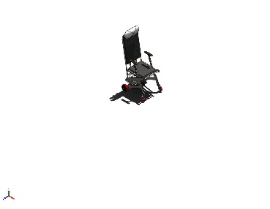 | Solid Body | Mass:0.0568757 kg  Volume:7.23794e-06 m^3  Density:7,858 kg/m^3  Weight:0.557382 N | c:\solidworks data (2)\browser\ansi metric\nuts\hex nuts\prevailing torque hex flange nut_am.sldprt  Jan 8 14:36:14 2025
EndChamfer  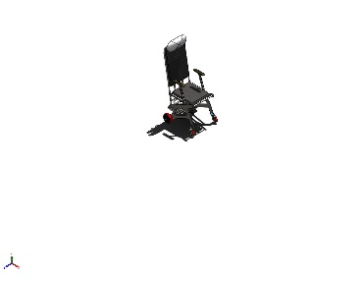 | Solid Body | Mass:0.0568757 kg  Volume:7.23794e-06 m^3  Density:7,858 kg/m^3  Weight:0.557382 N | c:\solidworks data (2)\browser\ansi metric\nuts\hex nuts\prevailing torque hex flange nut_am.sldprt  Jan 8 14:36:14 2025

Study Properties
Study name | Static 1
Analysis type | Static
Mesh type | Mixed Mesh
Thermal Effect: | On
Thermal option | Include temperature loads
Zero strain temperature | 298 Kelvin
Include fluid pressure effects from SOLIDWORKS Flow Simulation | Off
Solver type | Automatic
Inplane Effect: | Off
Soft Spring: | Off
Inertial Relief: | Off
Incompatible bonding options | Automatic
Large displacement | Off
Compute free body forces | On
Friction | Off
Use Adaptive Method: | Off
Result folder | SOLIDWORKS document (C:\Users\User\Desktop\All BE Designs\Solidworks\jetchair_it1)

Units
Unit system: | SI (MKS)
Length/Displacement | mm
Temperature | Kelvin
Angular velocity | Rad/sec
Pressure/Stress | N/m^2

Material Properties
Model Reference | Properties | Components
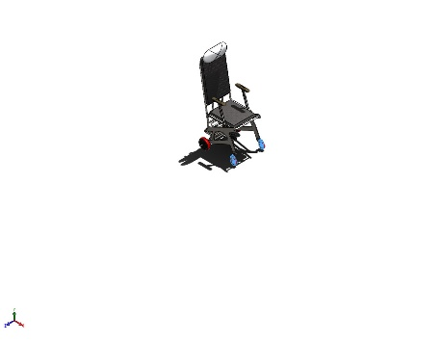 | Name: Alloy Steel  Model type: Linear Elastic Isotropic  Default failure criterion: Max von Mises Stress  Yield strength: 6.20422e+08 N/m^2  Tensile strength: 7.23826e+08 N/m^2  Elastic modulus: 2.1e+11 N/m^2  Poisson's ratio: 0.28  Mass density: 7,700 kg/m^3  Shear modulus: 7.9e+10 N/m^2  Thermal expansion coefficient: 1.3e-05 /Kelvin | SolidBody 1(Carriage Bolt^CCVINTAGE-PW-4S-STEM-1-solid1)(CCVINTAGE-PW-4S-STEM-1),  SolidBody 2(lock nut^CCVINTAGE-PW-4S-STEM-1-solid1)(CCVINTAGE-PW-4S-STEM-1),  SolidBody 3(SWIVEL^CCVINTAGE-PW-4S-STEM-2-solid1)(CCVINTAGE-PW-4S-STEM-1),  SolidBody 4(BUSHING^CCVINTAGE-PW-4S-STEM-1-solid1)(CCVINTAGE-PW-4S-STEM-1),  SolidBody 5(STAKED NUT^CCVINTAGE-PW-4S-STEM-1-solid1)(CCVINTAGE-PW-4S-STEM-1),  SolidBody 6(Stem^CCVINTAGE-PW-4S-STEM-1-solid1)(CCVINTAGE-PW-4S-STEM-1),  SolidBody 7(CCVINTAGE-WHEEL^CCVINTAGE-PW-4S-STEM-2/TREAD^CCVINTAGE-WHEEL_CCVINTAGE-PW-4S-STEM-2-solid1)(CCVINTAGE-PW-4S-STEM-1),  SolidBody 8(CCVINTAGE-WHEEL^CCVINTAGE-PW-4S-STEM-2/CCVINTAGE-WHEEL^CCVINTAGE-WHEEL_CCVINTAGE-PW-4S-STEM-1-solid1)(CCVINTAGE-PW-4S-STEM-1),  SolidBody 9(lock nut^CCVINTAGE-PW-4S-STEM-1-solid2)(CCVINTAGE-PW-4S-STEM-1),  SolidBody 10(CCVINTAGE-WHEEL^CCVINTAGE-PW-4S-STEM-2/BUSHING^CCVINTAGE-WHEEL_CCVINTAGE-PW-4S-STEM-1-solid1)(CCVINTAGE-PW-4S-STEM-1),  SolidBody 1(Carriage Bolt^CCVINTAGE-PW-4S-STEM-1-solid1)(CCVINTAGE-PW-4S-STEM-3),  SolidBody 2(lock nut^CCVINTAGE-PW-4S-STEM-1-solid1)(CCVINTAGE-PW-4S-STEM-3),  SolidBody 3(SWIVEL^CCVINTAGE-PW-4S-STEM-2-solid1)(CCVINTAGE-PW-4S-STEM-3),  SolidBody 4(BUSHING^CCVINTAGE-PW-4S-STEM-1-solid1)(CCVINTAGE-PW-4S-STEM-3),  SolidBody 5(STAKED NUT^CCVINTAGE-PW-4S-STEM-1-solid1)(CCVINTAGE-PW-4S-STEM-3),  SolidBody 6(Stem^CCVINTAGE-PW-4S-STEM-1-solid1)(CCVINTAGE-PW-4S-STEM-3),  SolidBody 7(CCVINTAGE-WHEEL^CCVINTAGE-PW-4S-STEM-2/TREAD^CCVINTAGE-WHEEL_CCVINTAGE-PW-4S-STEM-2-solid1)(CCVINTAGE-PW-4S-STEM-3),  SolidBody 8(CCVINTAGE-WHEEL^CCVINTAGE-PW-4S-STEM-2/CCVINTAGE-WHEEL^CCVINTAGE-WHEEL_CCVINTAGE-PW-4S-STEM-1-solid1)(CCVINTAGE-PW-4S-STEM-3),  SolidBody 9(lock nut^CCVINTAGE-PW-4S-STEM-1-solid2)(CCVINTAGE-PW-4S-STEM-3),  SolidBody 10(CCVINTAGE-WHEEL^CCVINTAGE-PW-4S-STEM-2/BUSHING^CCVINTAGE-WHEEL_CCVINTAGE-PW-4S-STEM-1-solid1)(CCVINTAGE-PW-4S-STEM-3)
Curve Data:N/A
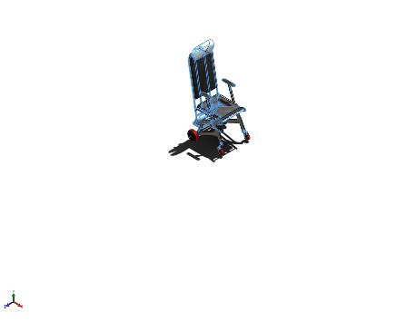 | Name: 1023 Carbon Steel Sheet (SS)  Model type: Linear Elastic Isotropic  Default failure criterion: Max von Mises Stress  Yield strength: 2.82685e+08 N/m^2  Tensile strength: 4.25e+08 N/m^2  Elastic modulus: 2.05e+11 N/m^2  Poisson's ratio: 0.29  Mass density: 7,858 kg/m^3  Shear modulus: 8e+10 N/m^2  Thermal expansion coefficient: 1.2e-05 /Kelvin | SolidBody 1(Fillet29)(Iteration1-1),  SolidBody 1(Chamfer4)(RS.177-4516-3000N-1/RS.177-4516-bottom-1),  SolidBody 1(Chamfer2)(RS.177-4516-3000N-1/RS.177-4516-bottom-mount-1),  SolidBody 1(Cut-Extrude1)(RS.177-4516-3000N-1/RS.177-4516-shaft-1),  SolidBody 1(Boss-Extrude2)(RS.177-4516-3000N-1/RS.177-4516-top-mount-1),  SolidBody 1(RecessCore)(RS.177-4516-3000N-1/pan cross head screw_as-2),  SolidBody 1(RecessCore)(RS.177-4516-3000N-1/pan cross head screw_as-3),  SolidBody 1(RecessCore)(RS.177-4516-3000N-1/pan cross head screw_as-4),  SolidBody 1(RecessCore)(RS.177-4516-3000N-1/pan cross head screw_as-5),  SolidBody 1(Dome1)(arm_rest-1),  SolidBody 1(Dome1)(arm_rest-2),  SolidBody 1(Cut-Extrude3)(beam_arm-1),  SolidBody 1(Cut-Extrude3)(beam_arm-2),  SolidBody 1(Fillet4)(bracket-1),  SolidBody 1(Fillet4)(bracket-2),  SolidBody 1(ThdSchPat)(heavy hex flange screw_am-2),  SolidBody 1(ThdSchPat)(heavy hex flange screw_am-4),  SolidBody 1(EndChamfer)(hex flange nut_am-1),  SolidBody 1(EndChamfer)(hex flange nut_am-3),  SolidBody 1(LPattern1)(pin_pipe-1),  SolidBody 1(EndChamfer)(prevailing torque hex flange nut_am-1),  SolidBody 1(EndChamfer)(prevailing torque hex flange nut_am-3)
Curve Data:N/A

Loads and Fixtures
Fixture name | Fixture Image | Fixture Details
Fixed-1 | 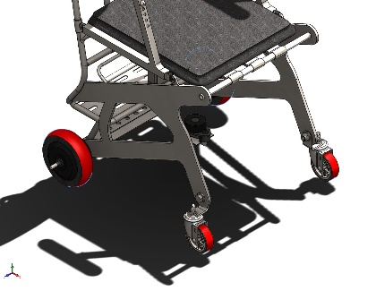 | Entities: 4 face(s)  Type: Fixed Geometry
Resultant Forces
Components | X | Y | Z | Resultant
Reaction force(N) | 0 | 0 | 0 | 1e-33
Reaction Moment(N.m) | 0 | 0 | 0 | 1e-33

Load name | Load Image | Load Details
Force-1 | 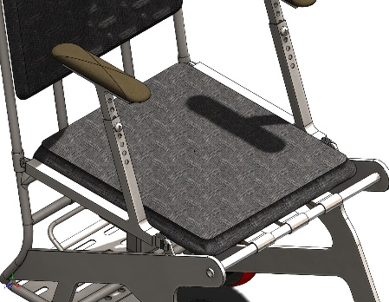 | Entities: 1 face(s)  Type: Apply normal force  Value: 1,500 N
Force-2 | 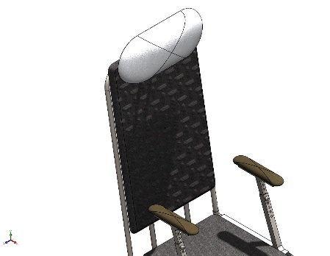 | Entities: 1 face(s)  Type: Apply normal force  Value: 300 N
Force-3 | 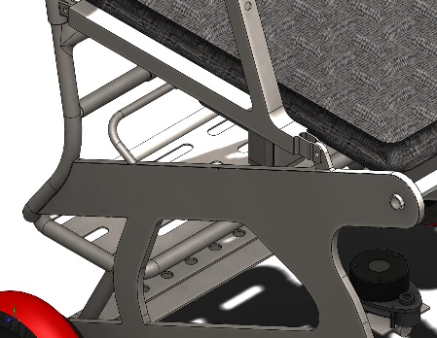 | Entities: 1 face(s)  Type: Apply normal force  Value: 300 N

Connector Definitions

Connector Name | Connector Details | Connector Image
Rigid Connector-1 | Entities: 2 face(s)  Type: Rigid | 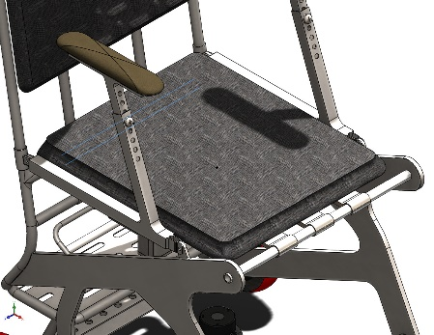  Rigid Connector-1
Rigid Connector-2 | Entities: 2 face(s)  Type: Rigid | 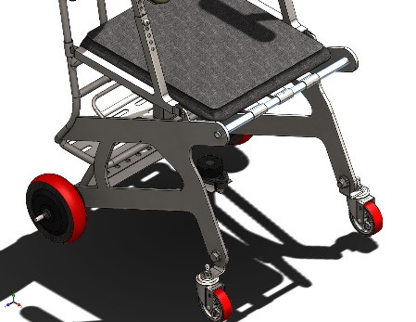  Rigid Connector-2
Rigid Connector-3 | Entities: 2 face(s)  Type: Rigid | 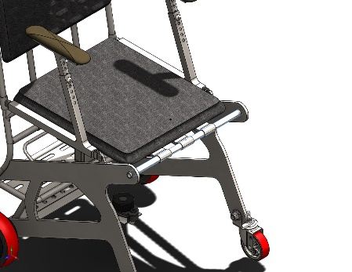  Rigid Connector-3
Rigid Connector-4 | Entities: 4 face(s)  Type: Rigid | 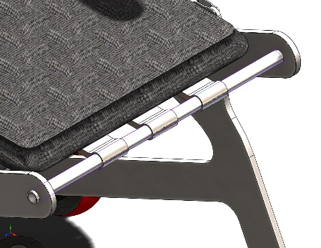  Rigid Connector-4

Pin/Bolt/Bearing Connector
Model Reference | Connector Details | Strength Details
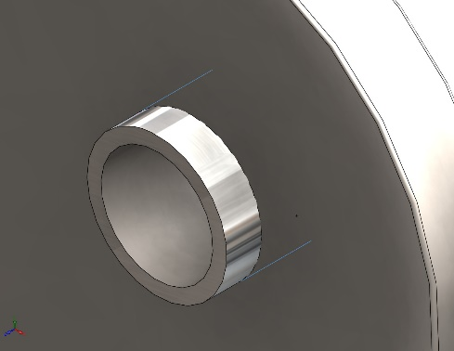  Bearing Support-1 | Entities: 1 face(s)  Type: Bearing | No Data
Connector Forces
Type | X-Component | Y-Component | Z-Component | Resultant
Axial Force (N) | 0 | 0 | -17.692 | 17.692
Shear Force (N) | 332.69 | 348.46 | 0 | 481.77
Bending moment (N.m) | 0 | 0 | 0 | 0

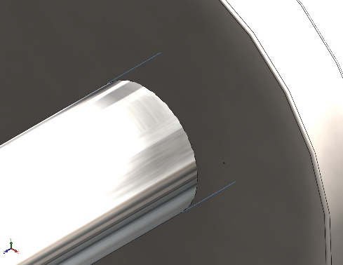  Bearing Support-2 | Entities: 1 face(s)  Type: Bearing | No Data
Connector Forces
Type | X-Component | Y-Component | Z-Component | Resultant
Axial Force (N) | 0 | 0 | -31.103 | 31.103
Shear Force (N) | 455.45 | 458 | 0 | 645.91
Bending moment (N.m) | 0 | 0 | 0 | 0

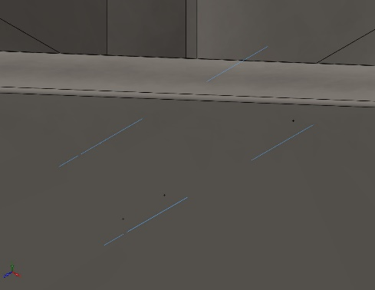  Pin Connector-2 | Entities: 3 face(s)  Type: Pin  With retaining ring (No translation): Yes  With key (No rotation): No  Connection Type: Distributed  Units: SI  Rotational stiffness value: 0 | No Data
Connector Forces Joint 1
Type | X-Component | Y-Component | Z-Component | Resultant
Axial Force (N) | 0 | 0 | 1.4553 | 1.4553
Shear Force (N) | -0.54373 | -0.038487 | 0 | 0.54509
Torque (N.m) | 0 | 0 | 1.4728e-13 | 1.4728e-13
Bending moment (N.m) | -0.0014149 | 0.00058712 | 0 | 0.0015319

Connector Forces Joint 2
Type | X-Component | Y-Component | Z-Component | Resultant
Axial Force (N) | 0 | 0 | 0.43409 | 0.43409
Shear Force (N) | 16.242 | 5.2715 | 0 | 17.076
Torque (N.m) | 0 | 0 | 1.4706e-13 | 1.4706e-13
Bending moment (N.m) | -0.04105 | 0.10186 | 0 | 0.10982

Connector Forces Joint 3
Type | X-Component | Y-Component | Z-Component | Resultant
Axial Force (N) | -0 | -0 | -0.43409 | -0.43409
Shear Force (N) | -16.242 | -5.2715 | 0 | 17.076
Torque (N.m) | 0 | 0 | 1.9427e-12 | 1.9427e-12
Bending moment (N.m) | 0.00552 | 0.0076134 | 0 | 0.0094039

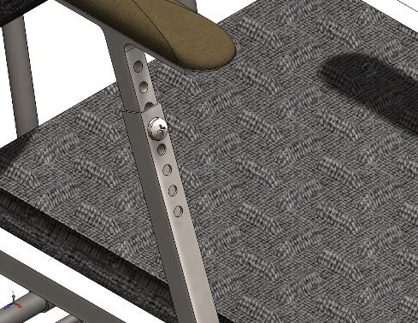  Pin Connector-3 | Entities: 3 face(s)  Type: Pin  With retaining ring (No translation): Yes  With key (No rotation): No  Connection Type: Distributed  Units: SI  Rotational stiffness value: 0 | No Data
Connector Forces Joint 1
Type | X-Component | Y-Component | Z-Component | Resultant
Axial Force (N) | 0 | 0 | 9.0217 | 9.0217
Shear Force (N) | -0.2788 | -0.15022 | 0 | 0.31669
Torque (N.m) | 0 | 0 | 4.6452e-15 | 4.6452e-15
Bending moment (N.m) | 0.0086488 | -0.027151 | 0 | 0.028495

Connector Forces Joint 2
Type | X-Component | Y-Component | Z-Component | Resultant
Axial Force (N) | -0 | -0 | -9.6997 | -9.6997
Shear Force (N) | 0.25393 | -0.26891 | 0 | 0.36986
Torque (N.m) | 0 | 0 | 1.4431e-13 | 1.4431e-13
Bending moment (N.m) | 0.033125 | 0.023406 | 0 | 0.04056

Connector Forces Joint 3
Type | X-Component | Y-Component | Z-Component | Resultant
Axial Force (N) | 0 | 0 | 9.6997 | 9.6997
Shear Force (N) | -0.25393 | 0.26891 | 0 | 0.36986
Torque (N.m) | 0 | 0 | 4.6576e-15 | 4.6576e-15
Bending moment (N.m) | 0.01891 | 0.02573 | 0 | 0.031932

Interaction Information

Interaction | Interaction Image | Interaction Properties
Global Interaction | 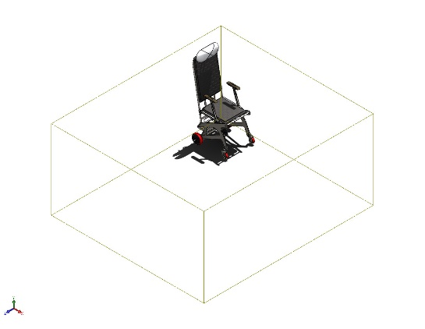 | Type: Bonded  Components: 1 component(s)  Options: Independent mesh

Mesh information
Mesh type | Mixed Mesh
Mesher Used: | Blended curvature-based mesh
Jacobian points for High quality mesh | 16 Points
Jacobian check for shell | Off
Maximum element size | 70.0328 mm
Minimum element size | 3.50164 mm
Mesh Quality | High
Remesh failed parts independently | Off

Mesh information - Details
Total Nodes | 421522
Total Elements | 221064
Time to complete mesh(hh;mm;ss): | 00:01:09
Computer name:

Sensor Details
No Data

Resultant Forces

Reaction forces
Selection set | Units | Sum X | Sum Y | Sum Z | Resultant
Entire Model | N | 0 | 0 | 0 | 1e-33

Reaction Moments
Selection set | Units | Sum X | Sum Y | Sum Z | Resultant
Entire Model | N.m | 0 | 0 | 0 | 1e-33

Free body forces
Selection set | Units | Sum X | Sum Y | Sum Z | Resultant
Entire Model | N | -0.00321075 | -0.256866 | -0.00055145 | 0.256887

Free body moments
Selection set | Units | Sum X | Sum Y | Sum Z | Resultant
Entire Model | N.m | 0.659999 | 0.191835 | 2.62447 | 2.71298

Beams
No Data

Study Results

Name | Type | Min | Max
Stress1 | VON: von Mises Stress | 0.000e+00N/m^2  Node: 1 | 2.985e+08N/m^2  Node: 69297
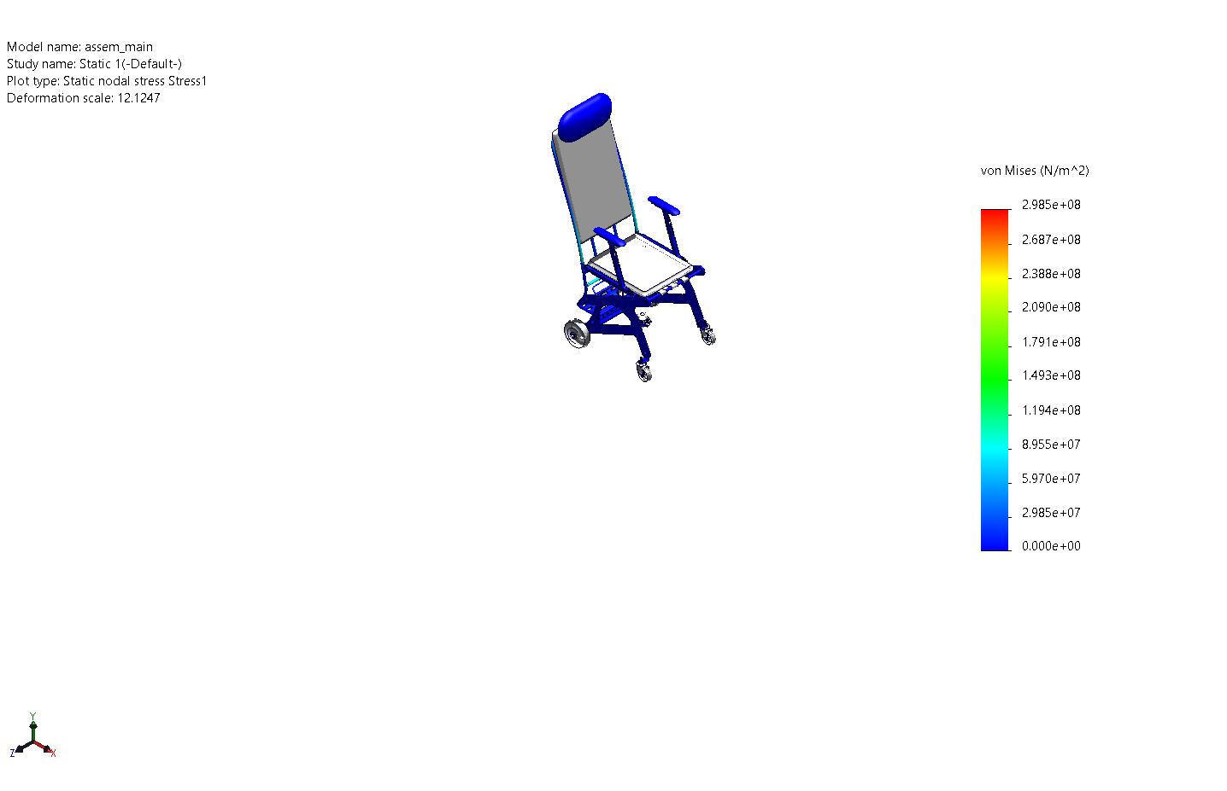
assem_main-Static 1-Stress-Stress1

Name | Type | Min | Max
Displacement1 | URES: Resultant Displacement | 0.000e+00mm  Node: 1 | 1.346e+01mm  Node: 69815
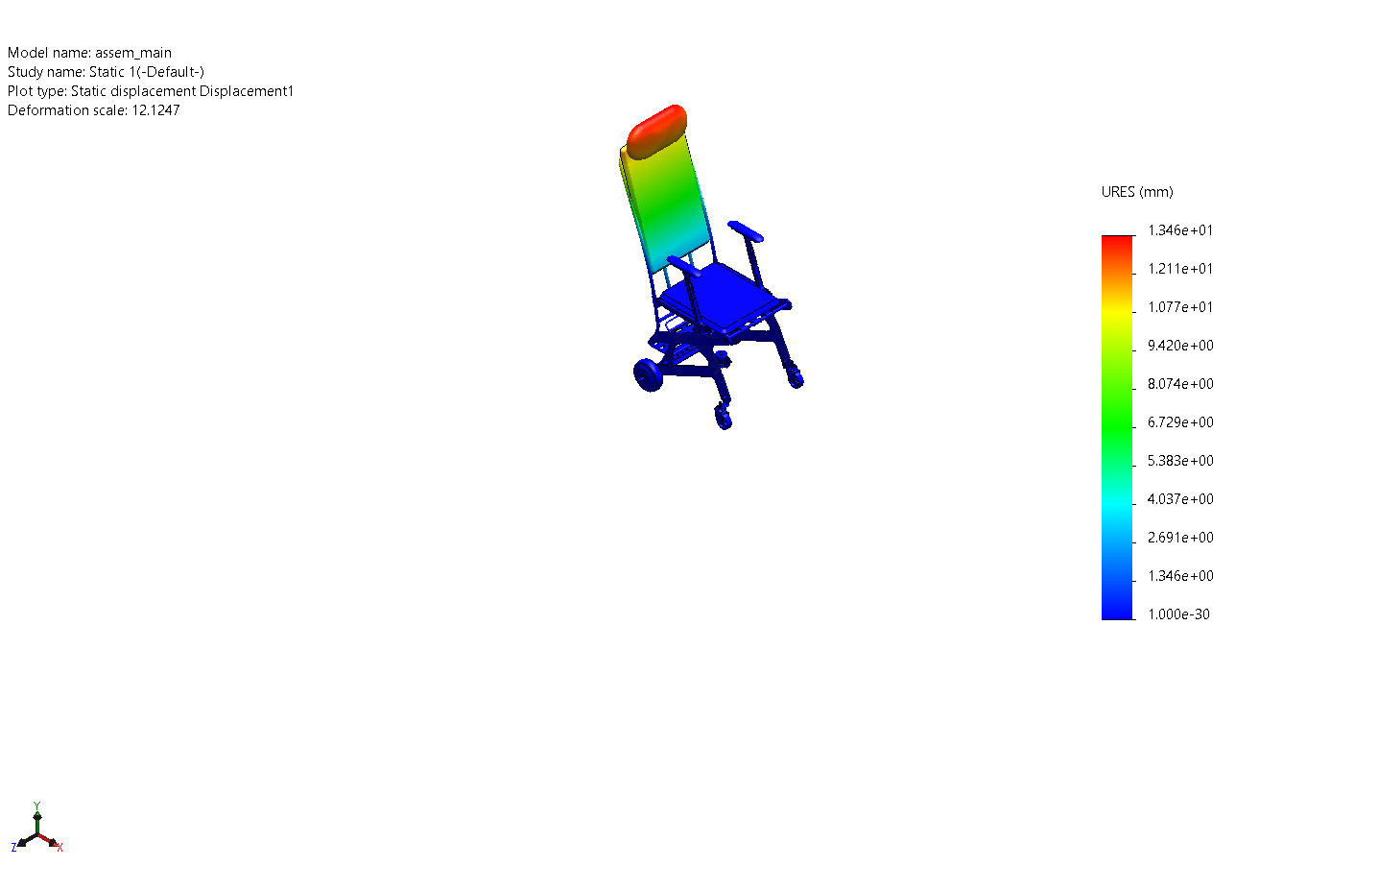
assem_main-Static 1-Displacement-Displacement1

Name | Type | Min | Max
Strain1 | ESTRN: Equivalent Strain | 0.000e+00  Element: 1 | 7.891e-04  Element: 91908
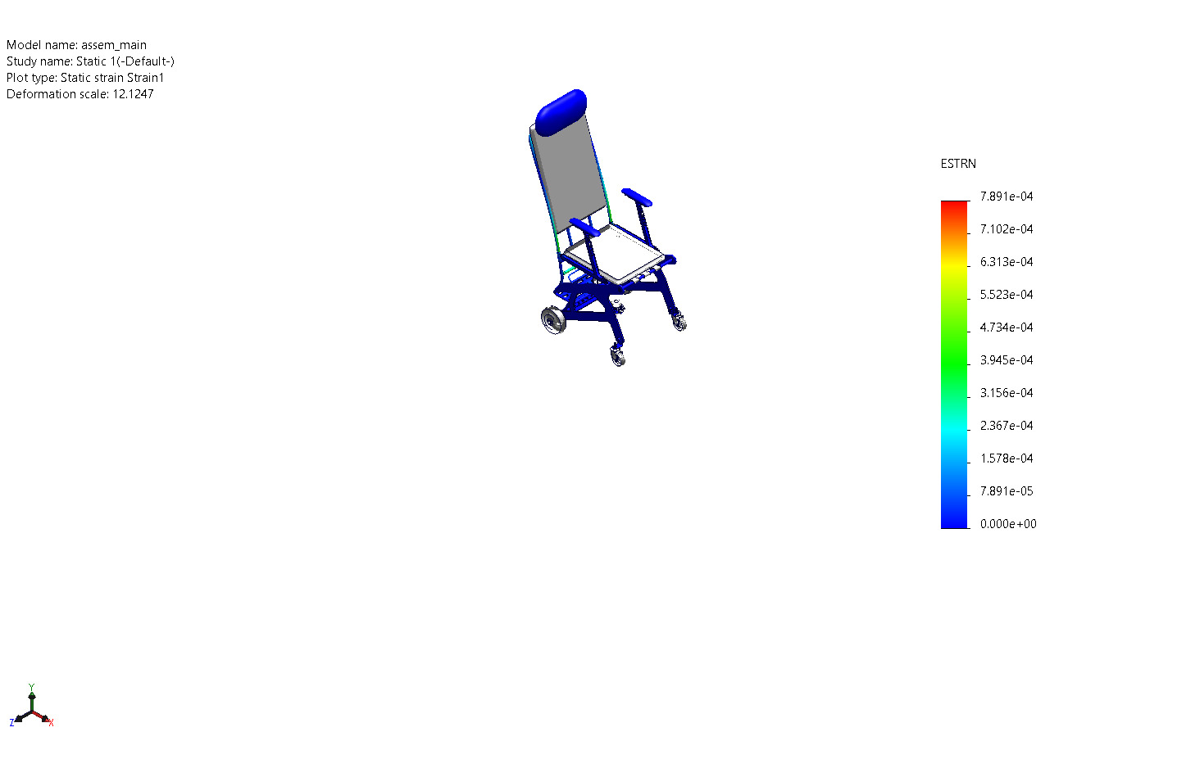
assem_main-Static 1-Strain-Strain1

Name | Type | Min | Max
Factor of Safety1 | Max von Mises Stress | 9.470e-01  Node: 69297 | 1.000e+16  Node: 6939
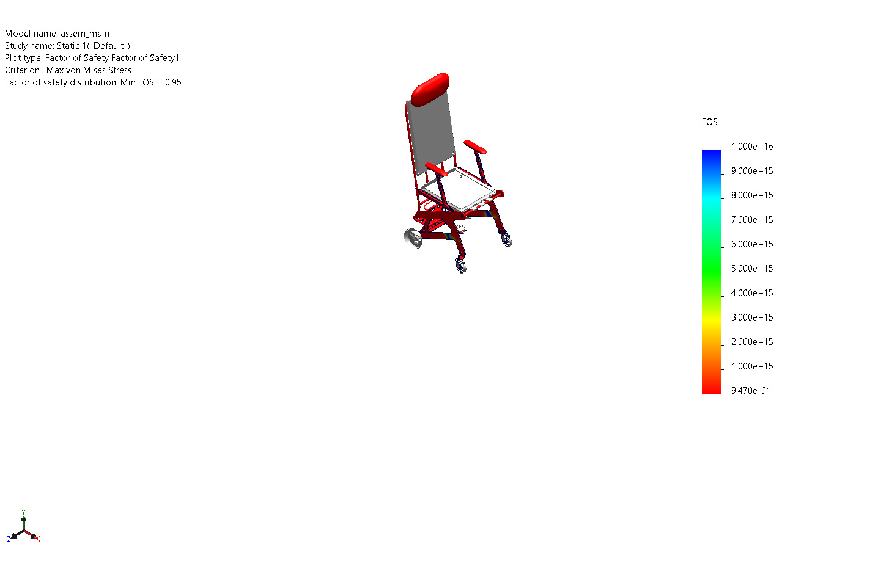
assem_main-Static 1-Factor of Safety-Factor of Safety1

Image-1

Image-2

Image-3

Image-4

Image-5

Conclusion

